CLL:113-Tut-3
Iterative Methods: Gauss Seidel, Jacobi, and SOR Gauss Seidel
Q1. Write a C program to solve N linear equations via Gauss Seidel and Jacobi method.
Q2.Upto 25 iterations draw the 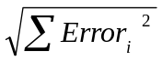vs k (k is the iteration number) for GS and Jacobi method for the following set of equations starting with initial guess of x⁽⁰⁾ = [1 2 1]^{T}.

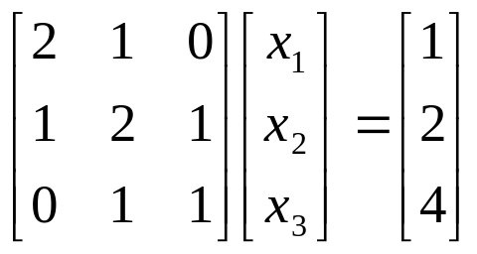
The convergence of Gauss Seidel technique can be speeded up using successive over-relaxation (SOR).
Q3. Solve the matrix in Q2, with the same guess values but with SOR with w=1.5 and make a comparative study with the GS method to see the convergence with iteration. (Do things via a computer program). The solution of the given set of equations are x = [3 -5 9]^{T}.

